**UNIVERSITY OF MUMBAI**

A PROJECT REPORT ON

**ONLINE MUSIC LIBRARY WITH**

**MUSIC PLAYER**

SUBMITTED BY

**Mr. Sourabh. S. Khaire**

Under the guidance of

**Prof. NITESH KUMAR**

**Master of Computer Applications (M.C.A.)**

Late Shri Vishnu Waman Charitable Trust’s

**VIVA SCHOOL OF M.C.A.**

**Shirgaon, Virar (East)**

**2017 – 18**



**CERTIFICATE**

This is to certify that

**Mr. Sourabh. S. Khaire**

Have satisfactorily completed the project entitled

( **ONLINE MUSIC LIBRARY WITH MUSIC PLAYER** )

Towards the partial fulfillment of the

MASTER OF COMPUTER APPLICATIONS (M.C.A.)

As laid by University of Mumbai.

**________________ ______________________ __________________**

**HOD External Examiner Internal Guide**

**Acknowledgement**

2

**We are extremely grateful and remain indebted to our guide Prof. NITESH KUMAR** **for being a source of inspiration and for their constant support in the Design, Implementation and Evaluation of the project.**

**We are thankful to him for his constant constructive criticism and invaluable suggestions, which benefited us a lot while developing the MINI project on “Employee Management System”.**

**He has been a constant source of inspiration and motivation of our hard work. He has been very co-operative throughout this project work. It would be our pleasure to express our thanks for their encouragement, co-operation and without which we might not be able to accomplish this project.**

**We express our gratitude to Prof. NITESH KUMAR** **sir for providing the information to carry out the project and to all staff members who were directly and indirectly instrument in enabling us to stay committed for the project.**

**Index**

|  |  |
| --- | --- |
| **SR. NO** | **TITLE** |
| 1 | Introduction to the Project |
|  | Introduction |
|  | Existing system |
|  | Scope |
|  | Operating Environment |
|  | Detailed Description of Technology Used |
| 2 | Proposed System |
|  | Introduction |
|  | Objective |
|  | User Requirements |
| 3 | Analysis & Design |
|  | Gantt Chart |
|  |  |
|  | Database Design |
|  |  |
| 4 | Hardware & Software requirement Specifications |
| 5 |  |
| 6 | Screenshots |
| 7 | Limitations |
| 8 | Future Enhancement |
| 9 | Conclusion |
| 10 | Bibliography |

**Introduction**

The main objective of developing this online web application, is to collect different MP3 songs of different categories and make a music library in one place where users can play and listen the latest songs at free of cost. This application also include a music Player to pick and play the songs from music library.

The design of this application mainly realizes three core functions including main play interface, menus (artist, album, all songs etc.) and song search.

Most of the websites now a day’s selling Music products through online but download music files with free of cost makes problem with piracy so this is the best way to stop music piracy over the internet.

One of the main advantage of this web application is accessibility, that is, it decreases manual effort and time where previously the users taking time for downloading the song. Here only you want an internet connection to listen music online.

This application has merits of high performance, simple operation, and run independently on the any web browser.

**Existing System**

* User can directly download the music files instead of listening it.
* Downloading the music file require time and storage page.
* It’s also creating case of piracy, as user can download file and can create his/her own website.

**Scope**

* To provide a convenient user-interface where the normal persons can also able to operate this website.
* For saving the time and storage of user which require while downloading a music file.
* To reduce the piracy of songs by providing security where user can only able to listen the song not able to download that song.

**Operational Environment**

* The product will be operating in windows environment. Also it will be compatible with the IE6.0. Most of the features will be compatible with the Mozilla Firefox & Opera 7.0 or higher version.
* This application has merits of high performance, simple operation, and run independently on the any web browser.

**Detailed Description of Technology Used**

1. **HTML**

Hypertext Markup Language (HTML) is the standard [markup language](https://en.wikipedia.org/wiki/Markup_language) for creating [web pages](https://en.wikipedia.org/wiki/Web_page) and [web applications](https://en.wikipedia.org/wiki/Web_application). With [Cascading Style Sheets](https://en.wikipedia.org/wiki/Cascading_Style_Sheets) (CSS) and [JavaScript](https://en.wikipedia.org/wiki/JavaScript), it forms a triad of cornerstone technologies for the [World Wide Web](https://en.wikipedia.org/wiki/World_Wide_Web).[[4]](https://en.wikipedia.org/wiki/HTML#cite_note-4) [Web browsers](https://en.wikipedia.org/wiki/Web_browser) receive HTML documents from a [web server](https://en.wikipedia.org/wiki/Web_server) or from local storage and render the documents into multimedia web pages. HTML describes the structure of a web page [semantically](https://en.wikipedia.org/wiki/Semantic_Web) and originally included cues for the appearance of the document.

1. **Java Script**

JavaScript is a very powerful client-side scripting language. JavaScript is used mainly for enhancing the interaction of a user with the webpage. In other words, you can make your webpage more lively and interactive, with the help of JavaScript. JavaScript is also being used widely in game development and [Mobile](https://www.guru99.com/mobile-testing.html) application development.

1. **Bootstrap**

Bootstrap is a [free and open-source](https://en.wikipedia.org/wiki/Free_and_open-source_software) front-end library for designing [websites](https://en.wikipedia.org/wiki/Website) and [web applications](https://en.wikipedia.org/wiki/Web_application). It contains [HTML](https://en.wikipedia.org/wiki/HTML)- and [CSS](https://en.wikipedia.org/wiki/CSS)-based design templates for [typography](https://en.wikipedia.org/wiki/Typography), forms, buttons, navigation and other interface components, as well as optional [JavaScript](https://en.wikipedia.org/wiki/JavaScript) extensions. Unlike many web frameworks, it concerns itself with [front-end development](https://en.wikipedia.org/wiki/Front-end_web_development) only.

1. **PHP**

Hypertext Preprocessor (or simply PHP) is a [server-side scripting](https://en.wikipedia.org/wiki/Server-side_scripting) language designed for [web development](https://en.wikipedia.org/wiki/Web_development) but also used as a [general-purpose programming language](https://en.wikipedia.org/wiki/General-purpose_programming_language).

PHP code may be embedded into [HTML](https://en.wikipedia.org/wiki/HTML) code, or it can be used in combination with various [web template systems](https://en.wikipedia.org/wiki/Web_template_system), web content management systems, and [web frameworks](https://en.wikipedia.org/wiki/Web_framework). PHP code is usually processed by a PHP [interpreter](https://en.wikipedia.org/wiki/Interpreter_(computing)) implemented as a [module](https://en.wikipedia.org/wiki/Plugin_(computing)) in the web server or as a [Common Gateway Interface](https://en.wikipedia.org/wiki/Common_Gateway_Interface) (CGI) executable. The web server combines the results of the interpreted and executed PHP code, which may be any type of data, including images, with the generated web page. PHP code may also be executed with a [command-line interface](https://en.wikipedia.org/wiki/Command-line_interface) (CLI) and can be used to implement [standalone](https://en.wikipedia.org/wiki/Computer_software) [graphical applications](https://en.wikipedia.org/wiki/Graphical_user_interface)

1. **MySQL**

MySQL is a fast, easy-to-use RDBMS being used for many small and big businesses. MySQL is developed, marketed and supported by MySQL AB, which is a Swedish company. MySQL is becoming so popular because of many good reasons −

* MySQL is released under an open-source license. So you have nothing to pay to use it.
* MySQL is a very powerful program in its own right. It handles a large subset of the functionality of the most expensive and powerful database packages.
* MySQL uses a standard form of the well-known SQL data language.
* MySQL works on many operating systems and with many languages including PHP, PERL, C, C++, JAVA, etc.
* MySQL works very quickly and works well even with large data sets.
* MySQL is very friendly to PHP, the most appreciated language for web development.

1. **Data structure**

Data structure introduction refers to a scheme for organizing data, or in other words a data structure is an arrangement of data in computer's memory in such a way that it could make the data quickly available to the processor for required calculations.

**Proposed System**

The Proposed System is a kind of library where different MP3 songs are manage in different categories. In this music library users can play and listen the latest songs at free of cost. This application also include a music Player to pick and play the songs from music library.

The design of this application mainly realizes three core functions including main play interface, menus (artist, album, all songs etc.) and song search.

**Objective**

In order to solve the problem of complex functions and large required memory of mobile phone or computer music player on the current market, this new web application i.e. **ONLINE MUSIC LIBRARY WITH MUSIC PLAYER** user-friendly is developed. This application has merits of high performance, simple operation, and run independently on the any web browser.

**User Requirements**

This project “ONLINE MUSIC LIBRARY WITH MUSIC PLAYER” is divided into following modules.

1. **Admin: -**

Admin (developer of this application) will collect all the Data for this application like Songs Names, Film/Album Names, Other metadata, and Play Link & Store in Data Base

1. **Main Interface: -** 
   1. Main interface implements all the basic commands for playback control like play, pause, stop, previous, next and volume control. It provides facilities to open previously saved play lists, show play list manager.
   2. Arranging all songs in three different categories that are *Albums, Artist, and All Songs,* whereall three categories will sorted in alphabetical order.
   3. Searching songs by accepting a keywords in searched bar.

**Analysis & Design**

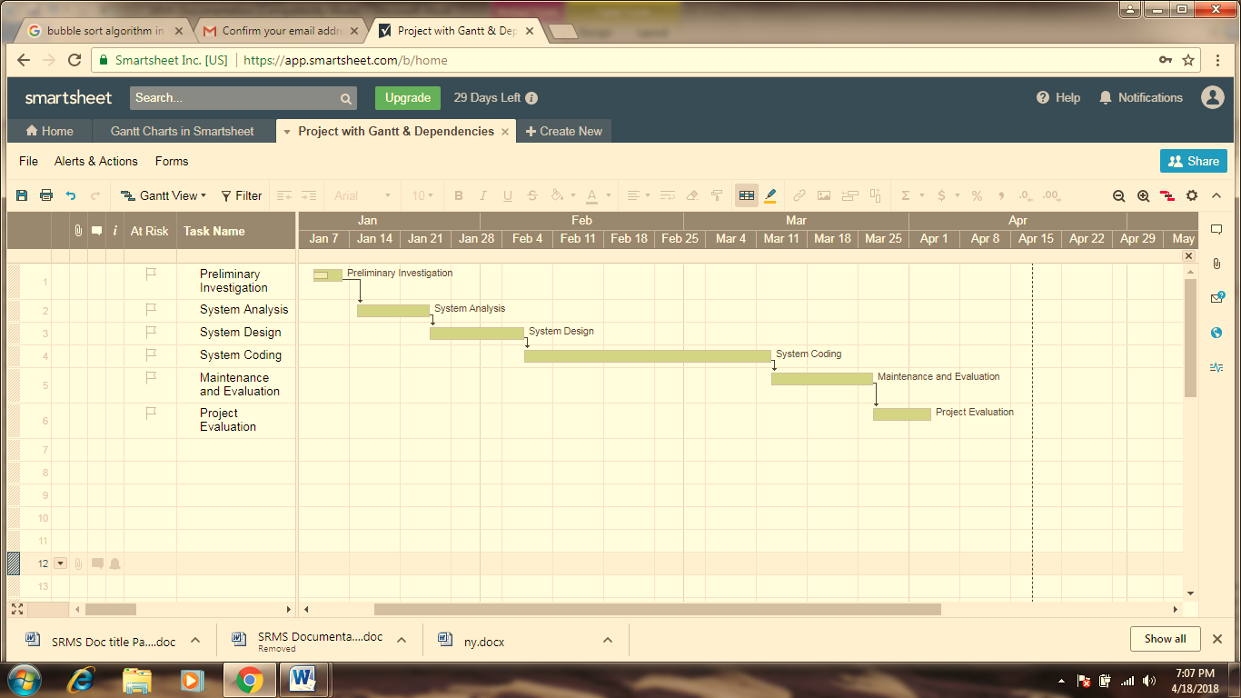**Gantt chart**

**Database Design** 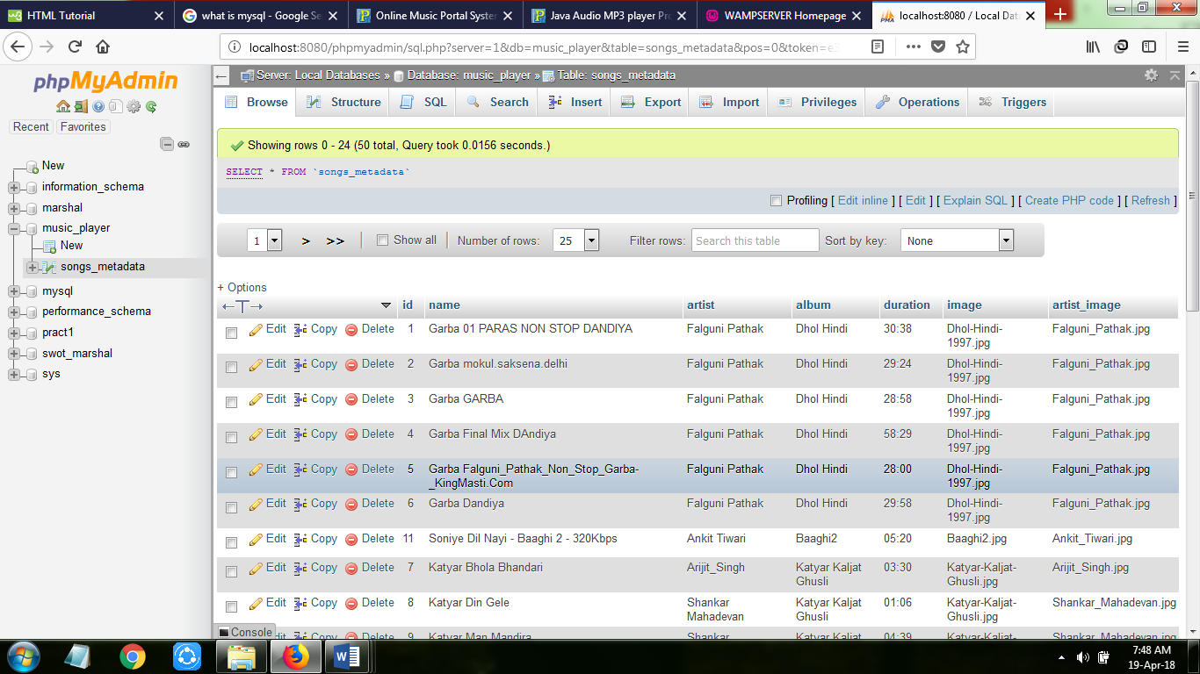

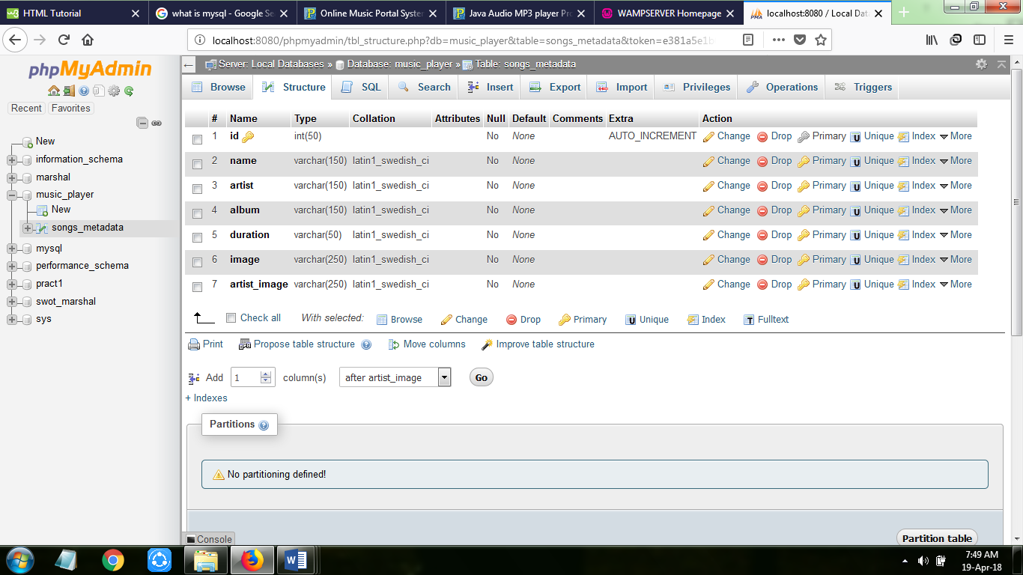

**Hardware & Software requirement Specifications**

**Hardware requirements**

Monitor : 17’’ CRT or LCD monitor

Keyboard : Normal or Multimedia

Mouse : Compatible mouse

**Software requirements**

User Interface Design : HTML, JavaScript, AJAX, JQuery, Bootstrap

Language Used : PHP

Tools : Wamp Server

Database Server : MySQL

Web Browser : Mozilla, Google Chrome, IE10, OPERA

**Screenshots**

Index.html

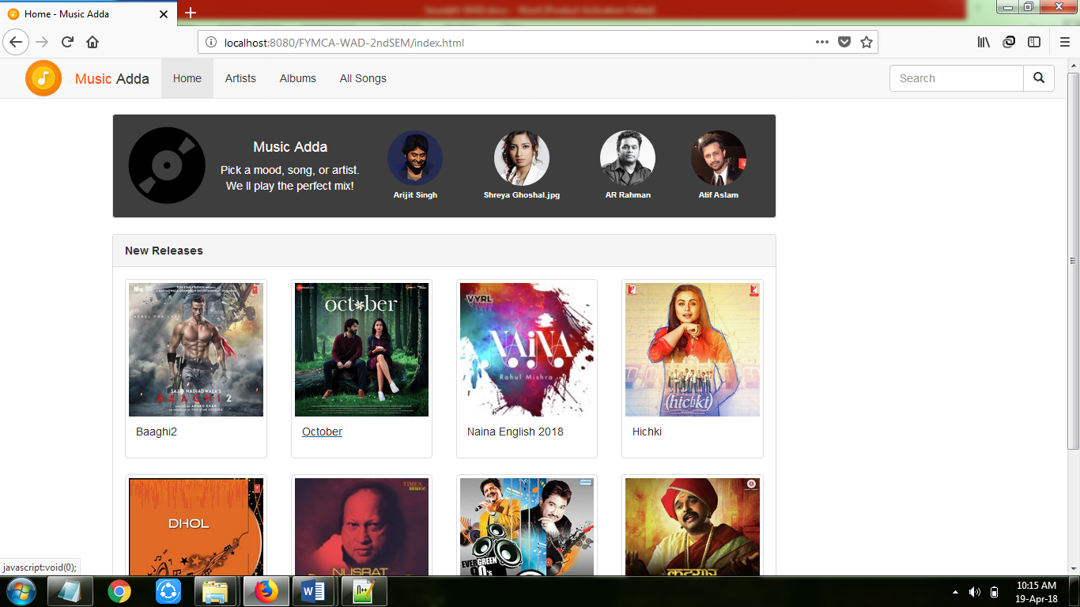

Category : album.html



Music_player.php

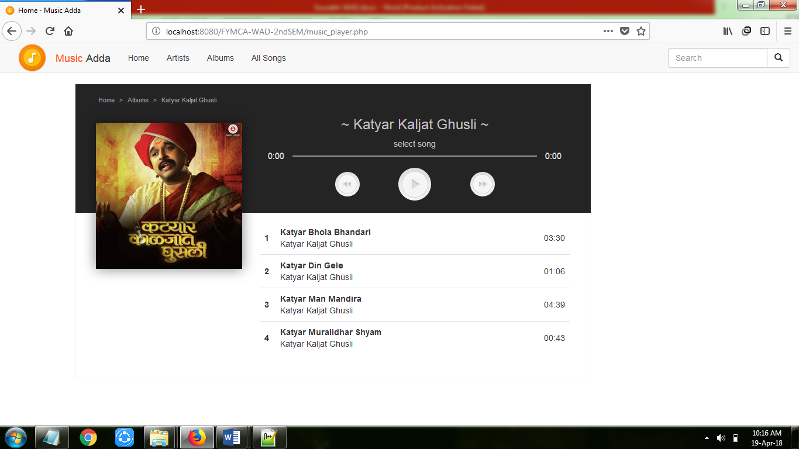

Searching a song : allsong.php

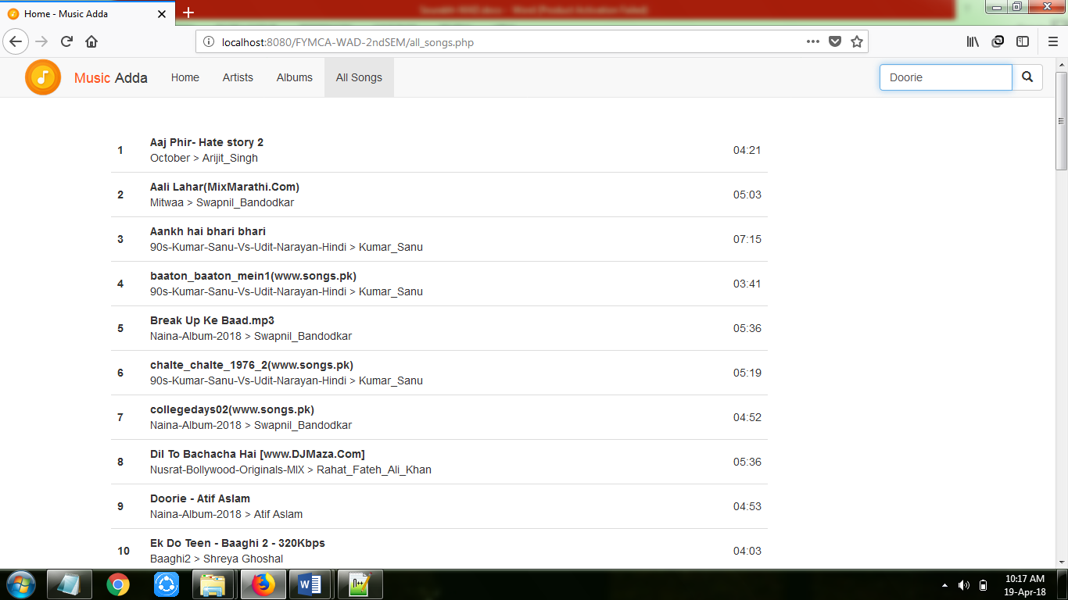

Song has been searched : allsong.php

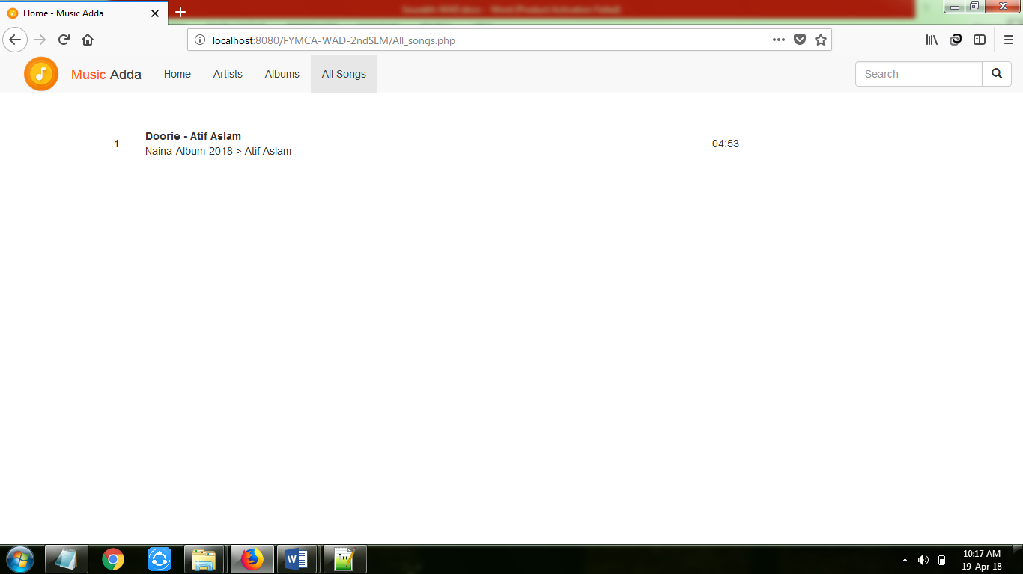

artist.php

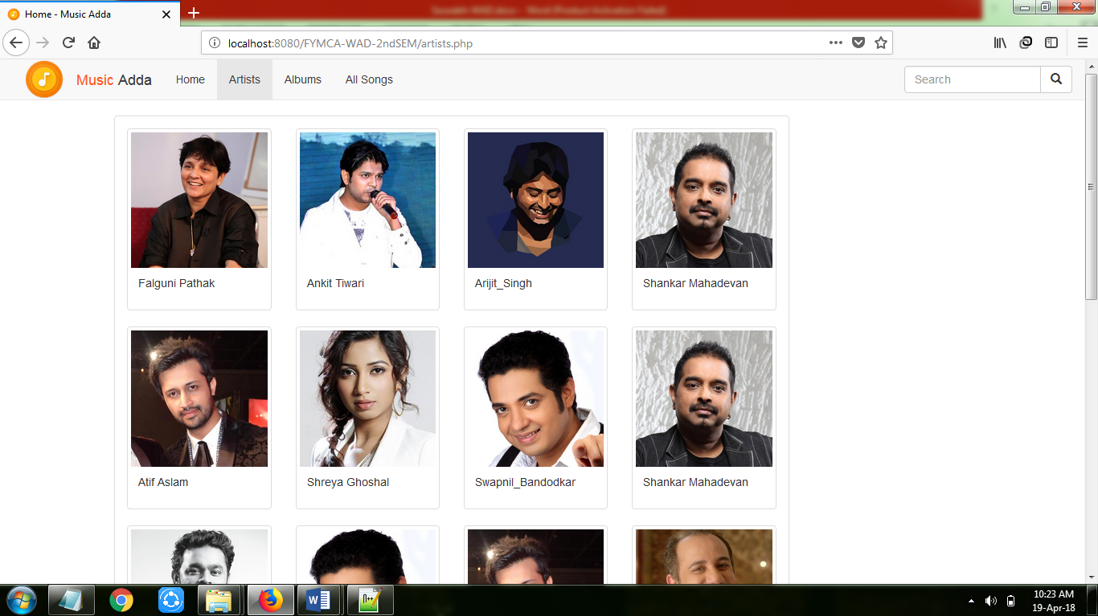

**Limitations**

* If Internet connection is slow it becomes difficult to fetch data from the database and execute the query.
* Server Problems.
* User cannot increase or decrease volume of music player.
* User can only able to play available song in database.
* User cannot play his/her own on this application.

**Future Enhancement**

Project can be updated in near future as and when requirement for the same arises, as it is very flexible in terms of expansion. The following are the future scope for the project.

* Addition of shuffle and repeat button.
* Addition volume button to increase or decrease volume of music player.
* Provide login panel for users.
* Users can create and delete their own playlist.

**Conclusion**

To conclude, the project being developed using PHP and MySQL Server is based on digitizing the physical efforts of maintaining large music files that can be accessed from any place at any time. This web application will also reduce the time require for downloading song. The limitations of the existing system led to the designing of the computerized system that is friendlier and more GUI oriented. The website is flexible for any future enhancements.

The project was successfully designed and is tested for accuracy and quality. All the objectives have been accomplished while constructing this application and this project meets the needs of the organization.

* Goals Achieved
* Reduced downloading effort. Reduced the speed require for downloading.
* Portable and flexible for further enhancement.
* Web enabled.
* Help to reduce piracy, that user not able to download any song and create their own website.

**Bibliography**



**Websites Referred:**

* [***www.1000projects.org***](http://www.1000projects.org)
* ***www.w3schools.com***
* ***https://www.wikipedia.org/***
* ***https://www.tutorialspoint.com/***